Multi-Class Jute Pest Image Classification Leveraging Advanced CNN Model’s

Prathap V   
*School of CSE & IS,*  
*Presidency University,*Bengaluru, India  
vprathap2004@gmail.com

Mangali Venkata Sandeep  
*School of CSE & IS,*  
*Presidency University,*Bengaluru, India  
venkatasandeep549@gmail.comAbilash G   
*School of CSE & IS,*  
*Presidency University,*Bengaluru, India  
abilashg432@gmail.com

B M Vineel Eshwar  
*School of CSE & IS,*  
*Presidency University,*Bengaluru, India  
vineelesh123@gmail.comAbhinav K   
*School of CSE & IS,*  
*Presidency University,*Bengaluru, India  
abhinavkesavan@gmail.com

Shailesh K R  
*School of CSE & IS,*  
*Presidency University,*Bengaluru, India  
krshailesh@gmail.com

*Abstract*— Jute (Corchorus species) is a major cash crop in   
several countries, and it plays a considerable role in most of these economies, particularly in South Asia. However,   
pest infestation is a major threat to jute production, reducing yield and quality. Pest identification by traditionally   
manual inspection of farmers and experts has its   
limitations: it is slow, tedious, and subject to human error. Thus,   
this research investigates the use of state-of-the-art machine   
learning (ML) and deep learning (DL) techniques,   
Xception, ResNet-50, and DenseNet-201 for automatic   
identification and classification of jute pests. The dataset   
corresponding to this activity comprises 17 different pest classes   
with a serious imbalance in their distributions. Preprocessing   
and data augmentation techniques were used to improve model   
performance. Different metrics-such as accuracy, F1-score,   
recall, and AUC-were used to evaluate the models. Xception   
received the highest accuracy of 99%, followed by ResNet-50   
which obtained 95% and DenseNet-201 achieved 86%. The   
findings demonstrate that deep learning models, especially   
Xception are extremely effective in detecting jute pests. This   
research, therefore, has opened up the scope for a reliable and   
fast automated system to identify pests to help farmers in   
executing timely management of pests whereby the process will   
lead to more sustainable farming practices and better jute yield.

Keywords— Jute Pest Classification, Deep Learning, Data Augmentation, Xception, Crop Management.

# Introduction

Although jute is called a "Golden Fiber" it is one of the agricultural economy cornerstones, especially in South Asia. The natural fibre is known for being one of the most versatile fibres widely used in textiles, ropes, and biodegradable packaging. Despite its importance on the economic level, the cultivation of jute has continued to have a lot of associated problems where pests have played a major role among those problems. It is said that pests lead to severe losses in either quality or yield of crops which create monetary problems for the farmer and increased dependence on the chemical pesticides for pest management. These raise questions about the environment and health, hence the need for sustainable and effective methods of pest management [2][4]. The use of artificial intelligence (AI) and machine learning (ML) in the agriculture sector has opened new avenues for tackling such problems. Using datasets tapped by various sensors and smart technologies, ML-based systems can be trained to monitor and predict various pest outbreaks [1]. These systems have gained ground in describing other crop disease-inflicted crops, indicating these techniques could be globally applicable to assist agriculture in improving the standard of human livelihoods [6].

Among the many techniques driven by AI, deep learning (DL) is deemed to be a game challenging to many complex agricultural problems. Particularly, convolutional neural networks (CNNs) have proven their capability for pest imaging and classification significantly better than any other method [3][7]. The recent improvements in DL models have shown that they are scalable and accurate and therefore can be applied to agriculture, particularly pest detection. Some studies like "Pest Detector" have demonstrated that the CNN-based models such as "Pest Detector" accurately identify the jute pests [8]. In the case of crops such as jute, where pest datasets are often imbalanced and show slight differences among classes, specialized approaches such as transfer learning and data augmentation become a necessity [5]. Pre-trained deep learning models for jute pest classification were shown to enhance the accuracy of them and very much address to limitation of small datasets [13]. These methods highlight the disappointing perspective of the cutting-edge DL to propel one towards better pest detection systems.

This research thus expands on these solutions by classifying the 17 kinds of jute pests with state-of-the-art deep learning models. By using architectures such as Xception, and ResNet as well as utilizing techniques to tackle the imbalance in the available datasets, the research will provide an impactful, automated solution for pest detection. The proposed technique enhances the evolution of Agricultural AI and eventually opens up for sustainable and more efficient farming that assures higher productivity with much lower environmental burden.

# Literature Review

Recently, pest classification approaches utilizing deep learning models have gained a large amount of attention because of their automated and accurate classifications by convolutional neural networks (CNN). A number of researchers have focused on various approaches and datasets in order to identify various types of pests in agriculture.

Islam et al. [10] presented a systematic discussion and thorough study concerning transfer learning models such as VGG16, ResNet101, DenseNet201, InceptionV3, Xception, and MobileNetV2 for jute pest classification. The study was performed on a dataset comprising 7235 images into 17 pest classes. Out of these, DenseNet201 achieved the highest performance at 97% accuracy, being an effective transfer learning model boosted to aid further by improving the pest classification performance. Sourav et al. [13] performed pest classification using VGG19 and transfer learning for four types of jute pests. The model had trained a data set of 1535 images and the classification result obtained was 95.86%, which showcases how fine-tuning of pre-trained models plays a critical role in pest identification tasks. Vignesh et al. [16] developed a deep convolutional neural network model to identify four common types of jute pests. The DCNN achieved an accuracy of 96.72% after training on the curated dataset of pest images. The performance evaluation involved various standard metrics such as recall, F1-score, confusion matrix, etc., thus establishing its scope in real-life applications in jute pest detection. Similarly, Karim et al. [8] introduced a deep CNN model named "Pest Detector," which is capable of detecting four vital jute pests faulty of which are the Field Cricket, Jute Stem Weevil, Spilosoma obliqua, and Yellow Mite. It managed to achieve remarkable training accuracies of 99.18% and 99.00% for validation on 2200 images, showing bright chances of real-time pest identification. Li et al. [11] developed YOLO-JD, a deep learning object detection model, to detect pests and diseases of jute. Using a dataset featuring mosquitoes and diseases, the model achieved 96.63% correctness, showing a considerably great opportunity for the YOLO model application with pests and diseases to point towards an effective area of administrative use in agriculture. Furthermore, Kasinathan et al. [9] developed a pest detection algorithm with the help of foreground extraction and contour identification techniques over the Wang, Xie, Deng, and IP102 datasets. Their technique with 9-fold cross-validation reported a classification rate of 91.5% and 90% for nine and 24 insect classes in the case of a CNN-based model. Malathi et al. [12] proposed a transfer learning-based methodology for pest identification in rice using a database of 3549 images. Data augmentation is applied to create diversity in the dataset, and the ResNet50 model gives an accuracy of 95.01%. In their work, it was demonstrated how transfer learning helps in classifying pests in the agricultural environment.

The reviewed studies show extraordinary progress in deep learning for detection of pests in jute. However, adding more classes of pest will enrich it further for better accuracy and possibly into real applications.

# Proposed Methodology

Our proposed methodology consists of four interconnected steps as follows. First, the collection of pest pictures to build a data set will be conducted. Second, augmentation of the dataset using augmentation techniques to increase sample size is done. This involves artificially creating new pictures using slight changes from the original image based on certain predefined parameters. Thirdly, we embrace the transfer learning with fine-tuning, in which pre-trained models are fine-tuned on the classification task. These models are taken from larger, pre-trained datasets and further fine-tuned on our dataset with appropriate layers and modifications so that they can learn the patterns present in the training dataset. Lastly, the models will then be validated on relevant performance metrics in the form of graphical representation to identify the most suited model. Fig.1 describes the overall flow of the proposed approach.

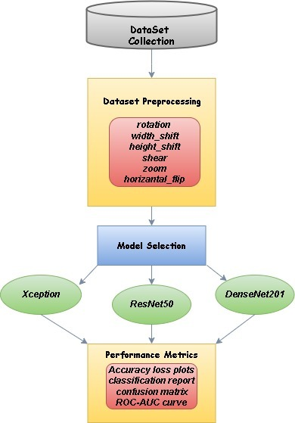

Fig.1: Overall Workflow of proposed approach

## Dataset Collection

The Jute Pest Dataset, [14] obtained from the UCI repository, is one that is freely available for use in research purposes. It consists of 7235 well-categorized images of jute pests in 17 classes. This is hoped to be a major contribution to agricultural research in providing a varying visual input towards studying and combating pest interference in jute crops. The dataset was reorganized for quality and uniformity through the removal of duplications and was subsequently split into three subsets in a ratio of 70% for training, 20% for validation, and 10% for testing. The other systematic arrangement allows for coming up with and evaluating very strong models for pest classification and detection. Fig.2 depicts sample images from the dataset.

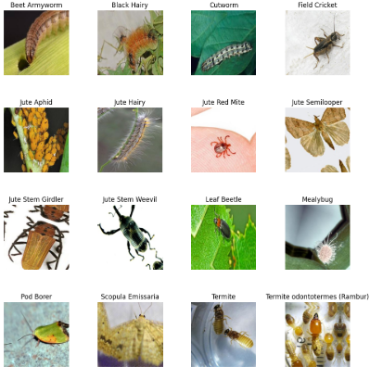

Fig. 2: Sample images from dataset.

## Dataset Preprocessing

Data preprocessing techniques are applied to the dataset with the aim to prepare the images for training with different models. First, images were rescaled so as to normalize the pixels pieces from 0 to 1 by dividing by 255. In order to improve generalization and minimize overfitting, several data augmentation techniques including random rotation within a 30-degree range, horizontal and vertical shifted by up to 20% of image dimensions from their original positions, random shearing, zoomed by up to 20%, and horizontal flipping of images were performed [18]. Before entering the ResNet50 and DenseNet201 models, images were resized to 224x224 pixels, whereas for Xception images were resized to 299x299 pixels.

## Model Selection

The models used for classification were ResNet50, Xception, and DenseNet201.These models have different architectures that allow them to demonstrate their effectiveness in various image classification tasks. The diversity in their methods provides a valuable comparison, highlighting the advantages and disadvantages of each model in identifying pests that impact jute.

### ResNet-50

ResNet are one of its fundamental architectures based on residual connections and have completely changed the landscape of deep learning applications by allowing the training of deep networks more effectively. Essentially, ResNet's most unique idea is that it actually uses skip connections or residual connections allowing gradient flow with relative ease during backpropagation. This reduces a vanishing gradient problem allowing deeper networks to learn more abstract features and improve performance on complex classification tasks such as jute pest detection. Despite this power, ResNet-50 requires a considerable amount of fine-tuning of hyperparameters to exploit full computational efficiency, whereas models that are less intensive can easily become slower in training [21].

### Xception

Xception is an advanced version of the inception architecture. The model employs depth-wise separable convolutions for reducing the computational load considerably while keeping one of the best performances in tasks where fine-grained feature recognition is needed. The two steps that the Xception convolution is divided into are the spatial step and the channel-wise step. It makes the network very efficient. Despite their efficacy for large-scale image classification tasks, Xception architectures are very sensitive to overfitting and therefore necessitate quite some regularization and data augmentation especially while dealing with imbalanced datasets like in the case of jute pest classification [15].

### DenseNet-201

The DenseNet-201 architecture consists of layers that are interconnected. Feature maps are densely conserved as a result. DenseNet-201 uses dense connection, which minimizes the number of parameters and allows for effective feature reuse. With its remarkable achievements in hierarchical feature learning, the method opens the door for effective learning, especially in classification problems with small class differences (like the jute pest dataset) [19]. By allowing the gradients to freely backpropagate, a dense connection avoids the vanishing gradient issue and improves deep network training. DenseNet201 does, however, consume a lot of memory, thus some fine-tuning is necessary to ensure that the model operates effectively and that overfitting doesn't happen [17].

## Performance Metrics

#### Precision: This metric indicates the proportion of true positive predictions to the total predicted positives. High precision means the model is making fewer false positive errors.

#### Recall: Recall measures the model’s ability to correctly identify actual positives. High recall indicates fewer false negatives.

#### F1 Score: This is the harmonic mean of precision and recall, providing a balanced measure of the model’s performance, especially when there is an uneven class distribution. .

#### Confusion Matrix: The output of a model, in terms of its predictions, is represented as a matrix known as the confusion matrix. It classifies the results into four major groups: True Negative (TN), False Positive (FP), True Positive (TP), and False Negative (FN). From the confusion matrix, we can determine the areas where the model is correct and where it fails to classify well, so we can target the mistakes that the model has made in the predictions. With regard to performance metric details, the tool provides critical ones that allow exact evaluation of accuracy in models mainly when distinguishing the classes.

#### AUC: AUC computes the area under the receiver operating characteristic (ROC) curve, which visualizes TPR versus false alarm rate. The area under that curve can summarize the curve characteristics in a single value. A 0.5 AUC shows lousy performance, while 0.7 is good, and 0.85 is excellent [20].

# Experimental Results

## Experimental Result of Xception

The Xception model performed amazing results on the jute pest classification task with an overall accuracy of 99% and both macro average and weighted average F1 Scores of 0.99. The classification report disclosed high precision, recall, and F1-scores for all 17 classes, with many classes attaining perfect metrics of 1.00. The confusion matrix supported the credibility of the model indicating few misclassifications with great diagonal dominance. It indicated only one misclassification in the several classes like Cutworm, Mealybug etc. Also, all classes displayed ROC curves that led to an AUC of 1.00 showing very high sensitivity of the model to differentiate. The earlier results confirm that the Xception model can handle the diverse and imbalanced dataset quite well with reliable predictions across all classes. Fig. 3 illustrates accuracy and loss curves, Fig. 4 presents classification report. Fig. 5 and 6 shows confusion matrix and ROC plot respectively.

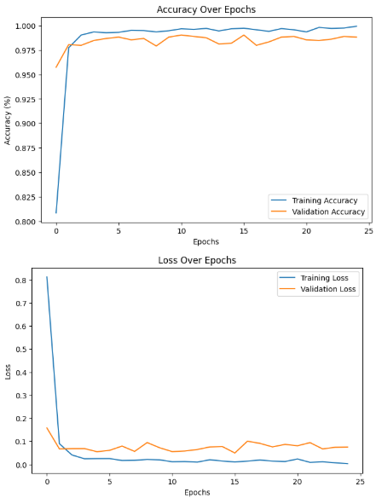

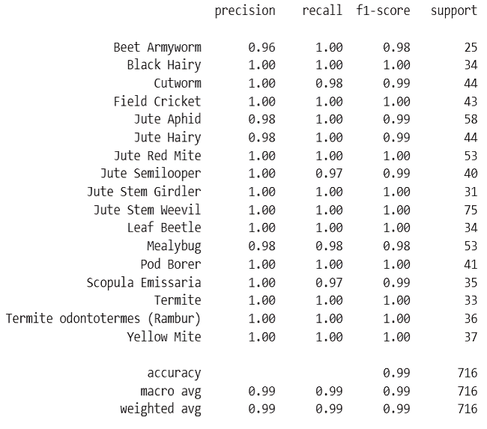Fig. 3: Accuracy and Loss plots of Xception model

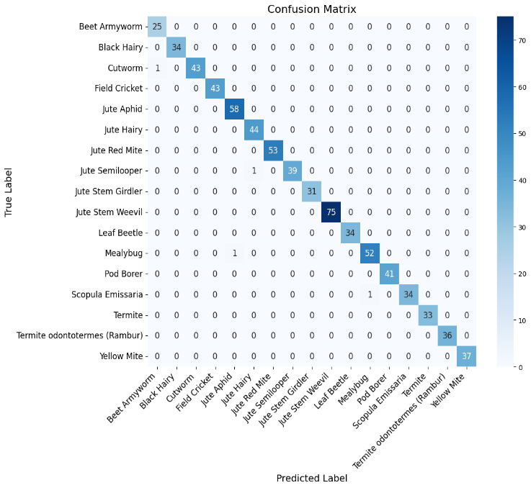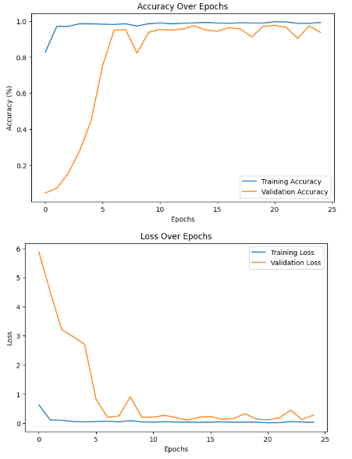Fig. 4: Classification Report of Xception model

Fig. 5: Confusion Matrix of Xception model

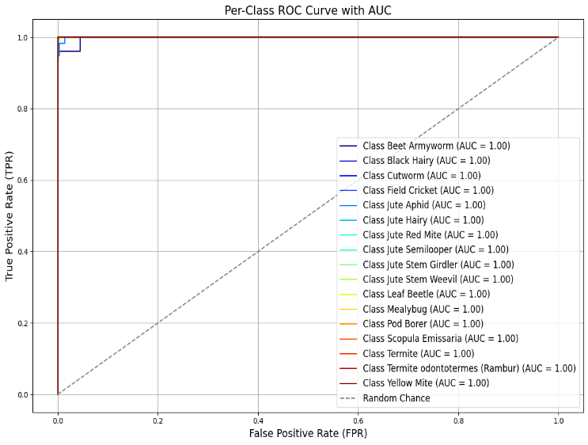

Fig. 6: ROC Curve of Xception model

## Experimental result of ResNet-50

The ResNet-50 model performed well in the classification of the jute pest, achieving an overall accuracy of 95%. It did excellently in the context of classes like Jute Red Mite, Termite, and Pod Borer justifying an F1-score of 1.00. The classes in which it performed somewhat lower were the Beet Armyworm with an F1-score of 0.80 and the Jute hairy with an F1-score of 0.90, signifying that more circles exist to improve precision and recall. The confusion matrix showed an overall small number of incorrect classifications, whereas some incorrect classifying render areas to improve on. The macro-average of 0.95 and a weighted average of 0.95 F1-scores and 1.00 AUC values justify a good position in the model, although imperfect identification remains for some hard categories. Fig.7 depicts Accuracy and Loss curves, followed by the classification report in Fig. 8. The confusion matrix in Fig. 9and the ROC curve in Fig. 10 further highlight the model’s effectiveness in differentiating jute pest classes.

Fig. 7: Accuracy and Loss plots of ResNet-50 model

Fig. 8: Classification Report of ResNet-50 model

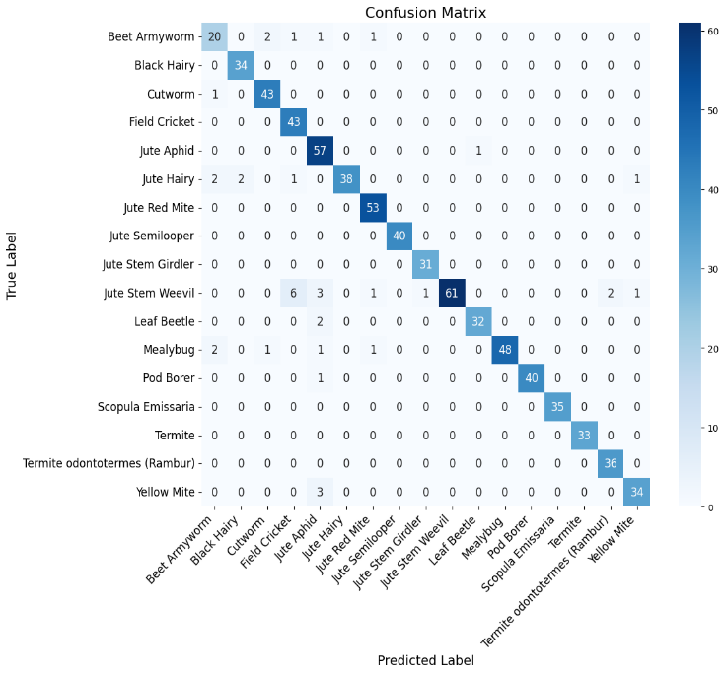

Fig. 9: Confusion Matrix of ResNet-50 model

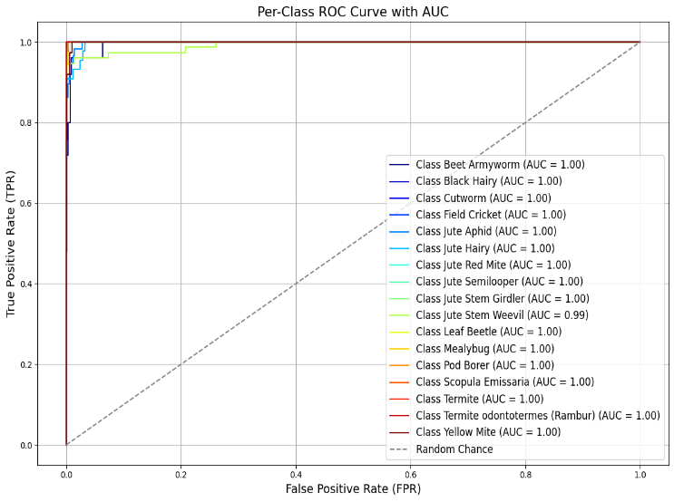

Fig. 10: ROC Curve of ResNet-50 model

## Experimental Result of DenseNet-201

The DenseNet-201 model showed moderate performance on the jute pest classification task reaching an overall accuracy of 86%. Although this model performed quite well on some classes such as Cutworm, Black Hairy, Mealybug, and Termite all scoring a perfect F1-measure of 1.00 in comparison to other pests like Jute Aphid (F1-measure: 0.79) and Beet Armyworm (F1-measure: 0.84) suffered due to possibly lower precision or recall. The macro-average F1-score and weighted-average F1-score were 0.86 and 0.87 respectively indicating scope for improvement especially, for difficult categories. The confusion matrix showed an overall diagonal dominance but misclassifications among certain classes revealed additional weaknesses in effectively handling those classes. K-values were quite high, mostly reaching 1.00. However, models have seen enough sensitivity in their general classification that they are still recommended for further optimization to work effectively across all classes.

Fig. 11 presents accuracy and loss curves, Fig. 12 shows the classification report, confusion matrix and ROC curve are illustrated in Fig. 13 and 14 respectively.

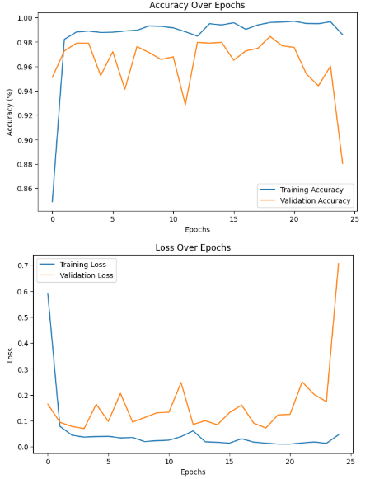

Fig. 11: Accuracy and Loss plots of DenseNet-201 model

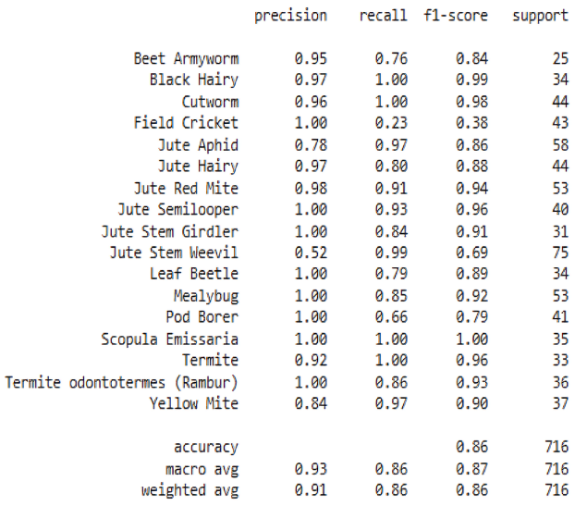

Fig. 12: Classification Report of DenseNet-201 model

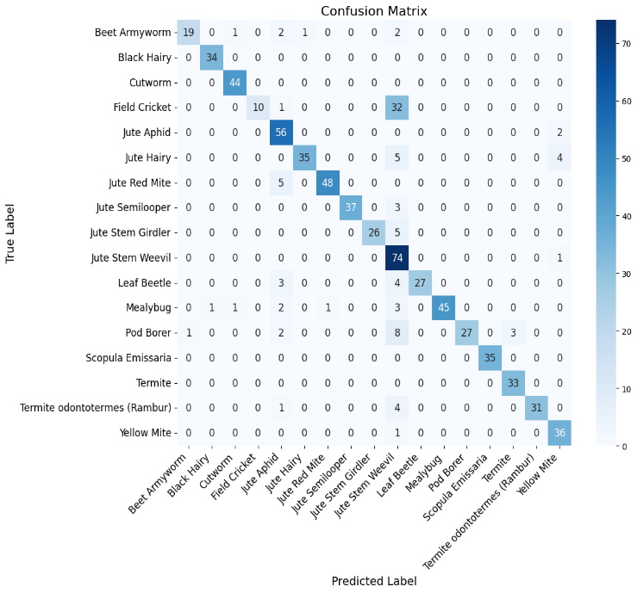Fig. 13: Confusion Matrix of DenseNet-201 model

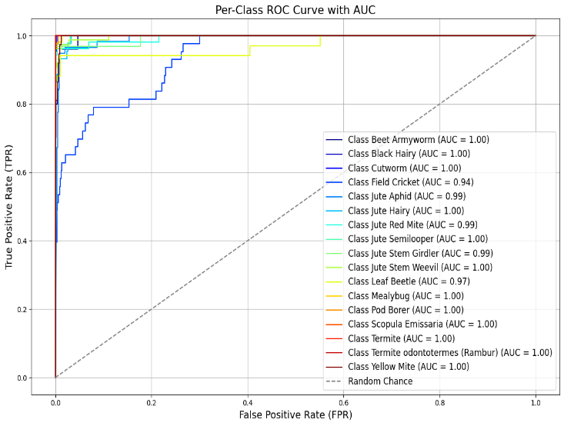

Fig. 14: ROC Curve of DenseNet-201 model

# Discussion and Future Work

Deep learning models have shown great potential in jute pest classification. However, a number of challenges remain open for consideration which must be addressed for their improvement of reliability for real-world applications. One of the most significant challenges arises because of very high visual resemblance amongst certain species of pests, resulting in wrong classifications. For example, pests such as Field Cricket and Jute Stem Weevil have some features in common, which builds up confusion in differentiating these two by the model. Also, such kind of imbalanced dataset, where some pest classes have quite a few images compared to others affects the generalizability of the model. Another thing would be the challenge from environmental differences. Factors like light change, leafy conditions, and background clutter can reduce model accuracy when applied in field conditions. Models such as ResNet50, Xception, and DenseNet201 indicate good performance. However, there still remain misclassifications indicated in the confusion matrix for some particular classes establishing the need for alternative refinements. Therefore, the future work will find a way to address challenges through widening and extending the dataset, where images would be gathered from different jute-growing regions so that the model would be able to keep in sight a broader spectrum of variations. Advanced architectures such as Vision Transformers and hybrid deep learning models will be explored further to obtain better classification accuracy as they may capture even finer details. Real-time deployment is another key area of development towards a lightweight and mobile-friendly system to help farmers and agriculturalists identify pests instantly at the field level. Explainable AI techniques such as Grad-CAM will cast more light on the model's decision-making process, thereby allowing users confidence in using it. These will address the research to develop a more accurate, scalable, and practical automated jute pest classification system that will have a very supporting role in pest management in agriculture.

# Conclusion

The study described here used deep learning models including Xception, ResNet-50, and DenseNet-201 for multi-class classification of jute pest species. Experimental findings revealed that Xception outperformed all other models with a validation accuracy of 99%, followed by ResNet-50 with 95% and DenseNet201 with 86% accuracy. This means Xception worked best among all models to disentangle complex classification tasks whilst affording the highest accuracy. There should be room for further future improvement in building a less time-consuming model. Also, ResNet-50 seemed promising but gave less accurate predictions than Xception. DenseNet-201, while the least accurate, highlights what might be extrapolated where this kind of classification is concerned. Deep learning models in this study have proven to accurately diagnose pests of jute and thereby support improved pest management and increased agricultural productivity. In the near future, other architectures will be explored for the task, computer resources optimized, and deep learning models integrated into real-life systems for scalable and automated pest management solutions.

# References

1. Marković, D.; Vujičić, D.; Tanas Kovic, S.; Đorđević, B.; Ranđić, S.; Stamenković, Z. Prediction of Pest Insect Appearance Using Sensors and Machine Learning. Sensors 2021, 21, 4846. <https://doi.org/10.3390/s21144846>
2. Saleem, M.H.; Ali, S.; Rehman, M.; Hasanuzzaman, M.; Rizwan, M.; Irshad, S.; Shafiq, F.; Iqbal, M.; Alharbi, B.M.; Alnusaire, T.S.; et al. Jute: A Potential Candidate for Phytoremediation of Metals—A Review. Plants 2020, 9, 258.

<https://doi.org/10.3390/plants9020258>

1. Ye, Haijian & Han, Hang & Zhu, Linna & Duan, Qingling. (2019). Vegetable Pest Image Recognition Method Based on Improved VGG Convolution Neural Network. Journal of Physics: Conference Series. 1237. 032018. 10.1088/1742-6596/1237/3/032018
2. Akter, Swapna & Sadekin, Md & Islam, Nazrul. (2020). Jute and Jute Products of Bangladesh: Contributions and Challenges. Asian Business Review. 10. 143-xxx. 10.18034/abr. v10i3.480.
3. Md. Simul Hasan Talukder, Mohammad Raziuddin Chowdhury, Md Sakib Ullah Sourav, Abdullah Al Rakin, Shabbir Ahmed Shuvo, Rejwan Bin Sulaiman, Musarrat Saberin Nipun, Muntarin Islam, Mst Rumpa Islam, Md Aminul Islam, Zubaer Haque. JutePestDetect: An intelligent approach for jute pest identification using fine-tuned transfer learning,Smart Agricultural Technology. Volume 5, 2023,100279, ISSN2772-3755, <https://doi.org/10.1016/j.atech.2023.100279>
4. Wijethunga C.D, Ishanka K.C, Parindya S.D.N, Priyadarshani T.J.N, Buddika Harshanath, and Samantha Rajapaksha, “Coconut Plant Disease Identified and Management for Agriculture Crops using Machine Learning”, int. j. eng. mgmt. res., vol. 13, no. 5, pp. 79–88, Oct. 2023.
5. Pakruddin B., Hemavathy R. (2024). Development of a Pomegranate Fruit Disease Detection and Classification Model using Deep Learning . Indian Journal of Agricultural Research. 58(2024): 1121-1130. doi: 10.18805/IJARe.A-6281.
6. D. Z. Karim, T. A. Bushra and M. M. Saif, "PestDetector: A Deep Convolutional Neural Network to Detect Jute Pests," 2022 4th International Conference on Sustainable Technologies for Industry 4.0 (STI), Dhaka, Bangladesh, 2022, pp. 1-6, Doi: 10.1109/STI56238.2022.10103326.
7. Thenmozhi Kasinathan, Dakshayani Singaraju, Srinivasulu Reddy Uyyala. Insect classification and detection in field crops using modern machine learning techniques, Information Processing in Agriculture. Volume 8, Issue 3, 2021, Pages 446-457, ISSN 2214-3173, <https://doi.org/10.1016/j.inpa.2020.09.006>
8. M. T. Islam and M. S. Rahman, "An Efficient Deep Learning Approach for Jute Pest Classification Using Transfer Learning," 2024 6th International Conference on Electrical Engineering and Information & Communication Technology (ICEEICT), Dhaka, Bangladesh, 2024, pp. 1473-1478, doi: 10.1109/ICEEICT62016.2024.10534395.
9. Li D, Ahmed F, Wu N, Sethi AI. YOLO-JD: A Deep Learning Network for Jute Diseases and Pests Detection from Images. Plants. 2022; 11(7):937.

<https://doi.org/10.3390/plants11070937>

1. Malathi, V., & Gopinath, M. P. (2021). RETRACTED ARTICLE: Classification of pest detection in paddy crop based on transfer learning approach. Acta Agriculturae Scandinavica, Section B — Soil & Plant Science,71(7),552–559. <https://doi.org/10.1080/09064710.2021.1874045>
2. Sourav, M.S.U., Wang, H. Intelligent Identification of Jute Pests Based on Transfer Learning and Deep Convolutional Neural Networks. NeuralProcessLett55,2193–2210(2023). <https://doi.org/10.1007/s11063-022-10978-4>
3. M. Islam. "Jute Pest," UCI Machine Learning Repository, 2024. [Online]. Available: <https://doi.org/10.24432/C5289P>.
4. F. Chollet, "Xception: Deep Learning with Depthwise Separable Convolutions," 2017 IEEE Conference on Computer Vision and Pattern Recognition (CVPR), Honolulu, HI, USA, 2017, pp. 1800-1807, doi: 10.1109/CVPR.2017.195.
5. S. Vignesh et al., "An Intelligent Method for Detecting Jute Pests Using Deep Convolutional Neural Networks," 2024 International Conference on IoT Based Control Networks and Intelligent Systems (ICICNIS), Bengaluru, India, 2024, pp. 1324-1329, doi: 10.1109/ICICNIS64247.2024.10823347.
6. Hou, Y., Wu, Z., Cai, X. et al. The application of improved densenet algorithm in accurate image recognition. Sci Rep 14, 8645 (2024). <https://doi.org/10.1038/s41598-024-58421-z>
7. Pakruddin, B., Hemavathy, R. (2024). A Systematic Review of Pomegranate Fruit Disease Detection and Classification Using Machine Learning and Deep Learning Techniques. In: Joshi, A., Mahmud, M., Ragel, R.G., Karthik, S. (eds) ICT: Innovation and Computing. ICTCS 2023. Lecture Notes in Networks and Systems, vol 879. Springer, Singapore. https://doi.org/10.1007/978-981-99-9486-1_13
8. G. Huang, Z. Liu, L. Van Der Maaten and K. Q. Weinberger, "Densely Connected Convolutional Networks," 2017 IEEE Conference on Computer Vision and Pattern Recognition (CVPR), Honolulu, HI, USA, 2017, pp. 2261-2269, doi: 10.1109/CVPR.2017.243.
9. Safari S, Baratloo A, Elfil M, Negida A. Evidence Based Emergency Medicine; Part 5 Receiver Operating Curve and Area under the Curve. Emerg (Tehran). 2016 Spring;4(2):111-3. PMID: 27274525; PMCID: PMC4893763.
10. Shafiq M, Gu Z. Deep Residual Learning for Image Recognition: A Survey. Applied Sciences. 2022; 12(18):8972. <https://doi.org/10.3390/app12188972>